Exploring Bluetooth Signal Strengths

Bluetooth and the world of IoT

Danyal Farooq

CS 456

Computer Science Department

Illinois Institute of Technology

Chicago, Illinois 60616

dfarooq@hawk.iit.edu

Alexander Nicoara

CS 456

Computer Science Department

Illinois Institute of Technology

Chicago, Illinois 60616

anicoara@hawk.iit.edu

***Abstract*—Bluetooth technology is being integrated more into our everyday technology in order give devices the capability to connect with each other and also eliminate the need for cords. With the expanding of world of the Internet of Things (abbreviated IoT), we explored the potential that Bluetooth has in becoming the leading wireless network protocol as a part of the next generation of IoT related technologies. This paper will give a general background of Bluetooth and it’s use in the modern world, as well as examine and test Bluetooth’s transmission capabilities. This paper will also discuss the method of experimentation and will conclude with the viability of Bluetooth being used in the future of IoT.**

***Keywords—Bluetooth, Arduino, IoT, Experiment, Signals***

# Introduction

[1] Created in 1994 by Jaap Haartsen and Sven Mattison of Swedish-owned telecommunications company *Ericsson*, Bluetooth was first explored as a wireless alternative to data cables. This technology uses short distance radio transmissions through the air to communicate data between two devices. As technology has progressed from then to our modern day, Bluetooth has unveiled more potential for our technological world to exist without the need of wires and cables. A wider variety of modern devices (such as smartphones, headsets, and tablets) have adopted the Bluetooth technology in order to have better flexibility in the exchange of data with different types of technological devices in a more centralized personal area network.

Today, Bluetooth is a technology that intrigues us. We see it in almost every electronic device we use each day, and it can be used anywhere without the need of connecting to a power outlet. For instance, we can go even as far as climb to the top of mount everest and connect our Bluetooth headphones to our own smartphones in order to listen to music. Realistically speaking, however, we do value Bluetooth for it’s ability to allow us to be mobile and more versatile, while still being connected to our devices. It gives a sense of automation, where we don’t have to travel very far or at all in order to interact with a piece of technology, and that it can be as easy as operating it from the palm of your hand.

After thinking about future possibilities for Bluetooth, we wondered how Bluetooth will fare in the upcoming IoT world, where most devices will even be more connected to each other. For example, Fridges will inform us when we need to buy more milk or if something is about to expire that needs to be eaten. Weight scales will be able to communicate with our computers to keep our fitness goals on track. In the future, cars might able to communicate with other cars to prevent accidents on the road too, and that is just breaking the surface of how the world of IoT might look like in the future. In order to get to that point, there must exist some type of network which would allow all of those device interactions with each other. We believe that Bluetooth holds the capability to serve the role of being that wireless communication protocol, however, we needed to prove further that Bluetooth’s capabilities are well suited for holding this role.

# Background

In order to test if Bluetooth should be considered as leading protocol for IoT, we needed to test how effective Bluetooth signal is in different conditions. In other words, we would test for packet loss when Bluetooth is exposed to different situations. Upon research, we came about a tutorial by Mohannad Rawashdeh on instructables.com [2]. Mr. Rawashdeh showed how a Bluetooth module can be connected with an Arduino to transmit data. He detailed that we need the following materials. (Fig. 1 shows those materials with the corresponding numbers)

1. Arduino Uno
2. Bluetooth Module (HC-06)
3. Solderless Jumper
4. Battery
5. Battery Cable

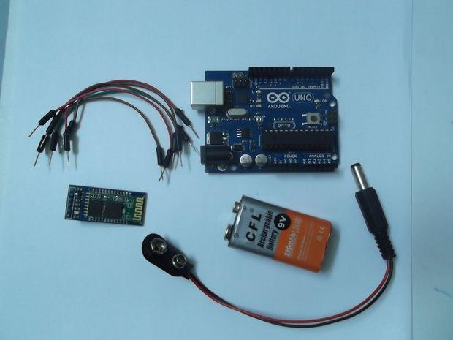

1. Materials needed for the experiments.

First, we would need to program the Arduino control the Bluetooth module to send some data. We would then connect the Bluetooth module to the Arduino. After that, we would connect the Bluetooth with the laptop and use the serial monitor in the Arduino software to see the data sent. In order to connect the Bluetooth module to the Arduino connection were need to be made with the jumpers and Mr. Rawashdeh detailed how, which is shown in Fig. 2.

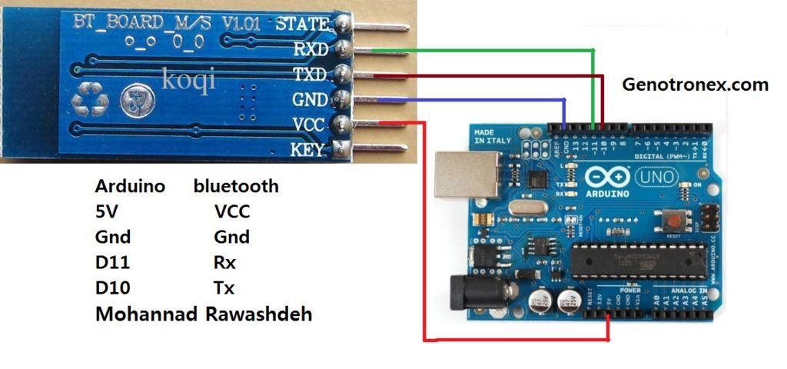

1. Connection from the Bluetooth module to the Arduino Uno.

# Approach

Our approach was simple. We would keep the laptop stationary and move the Bluetooth module around in different positions and situations to test for packet loss. We first started with the Bluetooth right next to the computer as shown in Fig. 3.

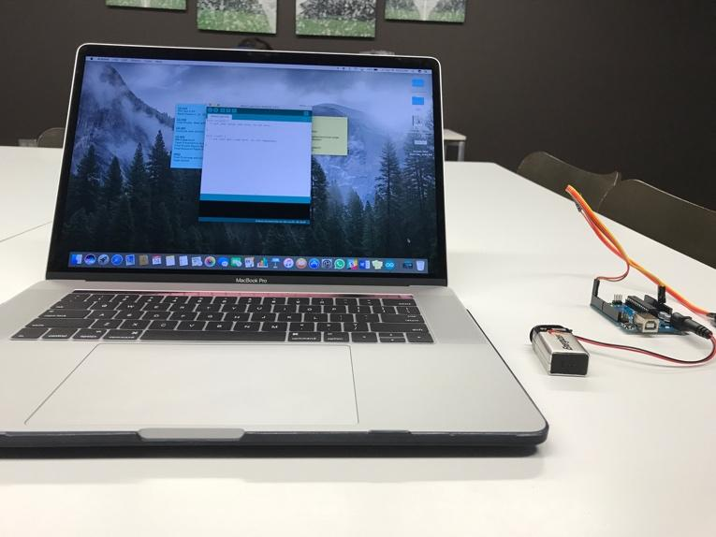

1. Bluetooth setup next to the laptop.

With this setup, we used the serial monitor in the Arduino software and received one number every second, as we programmed. Fig. 4 shows the data that we received. The last line, ‘10011’, is the total time spent transmitting.

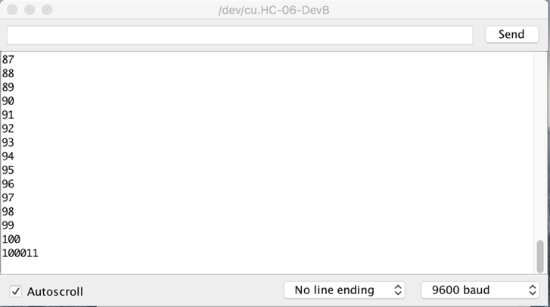

1. Serial output received from Bluetooth module.

We then positioned the Bluetooth module far away, and we obtained the same results. So we went even further, and we obtained the same results. Then we kept going further, until it disconnected. With these experiments, we found that Bluetooth has no packet loss at all. In other words, we expected that we would receive the some numbers and not others. However, we received all the data, until the Bluetooth just disconnected as its signal strength was too weakened.

After discovering this, we chose to change the way we would evaluate Bluetooth’s transmission performance. We only kept the experiment the same for testing the range of the Bluetooth. However, in other situations, we used the Macbook’s built in Bluetooth signal strength detector to observe signal strength. Our procedure for all experiments was to take the signal strength three times, once every twenty seconds. In all, we tested Bluetooth in four different types of situations.

### We tested Bluetooth’s overall range with the packet transfer method. We kept the laptop stationary and kept increasing the distance of the Bluetooth module until it disconnected.

### We tested Bluetooth signal strength when it's five inches away from the laptop. Then when there was 15 ft and 1 wall separating the laptop and the module. Then when there was 30 ft and 2 walls separating the laptop and the module. And finally, when there was 45 ft and 3 walls separating the laptop and the module.

### We tried to simulate various IOT devices the Bluetooth would be embedded in. We kept the laptop stationary and Bluetooth module stationary with a static distance of 10ft. We look one reading without any material covering the module. Then we took readings with various materials covering the modules: paper, shirt, plastic, cardboard, and metal.

### We wanted to see how Bluetooth would fair with wifi interference. We took readings with a static distance of 20 ft between the laptop and the Bluetooth module. One, there were some wifi networks interfering. Two, there were many wifi networks interfering. We wanted to go to a somewhere without any networks detected; however that is very difficult to find in this urban, Chicago setting.

# Result

After conducting all the experiments. We were left with the much data. We discovered that the Bluetooth module actually has a range of 67 meters. For experiments 2, 3, and 4, Table 1, Table 2, Table 3 contain its respective results.

|  |  |  |  |
| --- | --- | --- | --- |
| **Walls** | **Signal Strength in dBm** | | |
| ***20 Seconds*** | ***40 Seconds*** | ***1 Minute*** |
| 5 inches and no wall | -43 | -44 | -44 |
| 15 ft and 1 wall | -54 | -60 | -59 |
| 30 ft and 2 walls | -68 | -70 | -71 |
| 45 ft and 3 walls | -78 | -78 | -79 |

1. How walls affect signal strength

|  |  |  |  |
| --- | --- | --- | --- |
| **Materials** | **Signal Strength in dBm** | | |
| ***20 Seconds*** | ***40 Seconds*** | ***1 Minute*** |
| No Material | -55 | -55 | -56 |
| Paper | -53 | -54 | -54 |
| Shirt | -56 | -56 | -57 |
| Plastic | -54 | -53 | -53 |
| Cardboard | -55 | -56 | -56 |
| Metal | -69 | -76 | -75 |

1. How materials affect signal strength

|  |  |  |  |
| --- | --- | --- | --- |
| **Wi-Fi Interference** | **Signal Strength in dBm** | | |
| ***20 Seconds*** | ***40 Seconds*** | ***1 Minute*** |
| Some interference | -64 | -67 | -64 |
| Much interference | -69 | -71 | -68 |

1. How Wi-Fi interference affects signal strength

Fig. 5 shows how much Wi-Fi interference there was during during some interference.

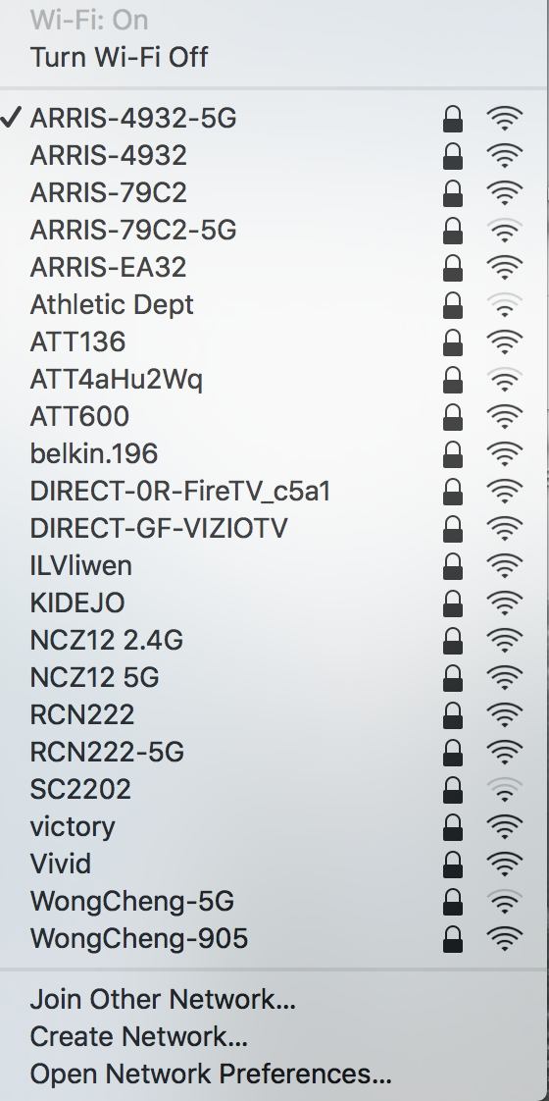

1. Wi-Fi interference considered as some interference.

Fig. 6 shows how much Wi-Fi interference there was during much interference.

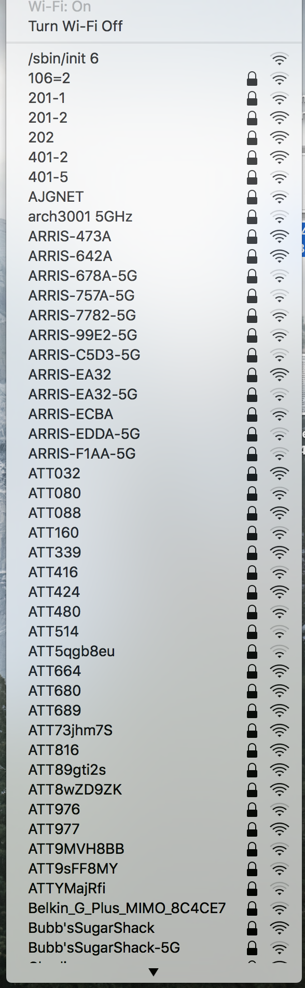

1. Wi-Fi interference considered as much interference.

# Conclusion and Discussion

One very clear conclusion we can draw from our experiments is that the theoretical range of the Bluetooth is not the said 100 meters. We obtained a measurement of 67 meters. One of the main factors outside of the experiment which could justify the reduced signal range is most likely to be other WiFi and wireless signals in the air. With this being said as well as Bluetooth’s all-or-nothing connection behavior, we believe that Bluetooth would not perform as well in larger environments with more people, such as at a concert or in the downtown area of a city.

Since Bluetooth’s signal was also affected by metal and (according to the laws of physics) could potentially be by other materials that manipulate electromagnetic waves, Bluetooth devices in certain science laboratories would be more likely to fail or function improperly because the signal can’t get to it’s destination. Walls are also an obstacle that can prevent good bluetooth signal quality, as some can be composed of metal or steel.

With all this said, we can finally conclude that Bluetooth would serve it’s best role as a protocol to use in a smaller setting, such as a home or office. As there are small number of walls, a smaller which a person can move around, and not much signal interference from other Wi-Fi. Even moreso, we believe that Bluetooth is also great to use for wearable technology, such as smartwatches or earbuds, since clothing and other thin fabric materials don’t affect Bluetooth signal strength very much.

Unfortunately, we do not think that Bluetooth will be the best protocol for moving forward in the IoT world. While Bluetooth may serve as a short-range solution, the main protocol should have the capability to function well in both small and large settings, in addition to having more stable connection. We aren’t sure how or when this type of wireless technology will arise, but we can only speculate and continue to research ideas, which could potentially end up leading to a solution one day.

# Future Work

We want to test Bluetooth in many more situations. One could be in various climates. Could we actually connect our wireless headphones to our smartphones on top of Mount Everest? By doing this, we can see how well devices can still connect with each other in regards to weather. As we continue to develop new technology to reach the higher and more extreme limits of the world and even space, we want to ensure that our technology still can effectively communicate well in the midst of harsh conditions.

Another cool idea to consider is cars. We want to see how well Bluetooth can perform in motion. If two cars are both moving, could they communicate effectively with one another through Bluetooth? Researching more into this could get engineers better insight on car safety, awareness, and would give new ideas on how cars could potentially drive themselves one day.

Lastly, we want to compare Bluetooth with other protocols like Wi-Fi and ZigBee, in various conditions. This is truly allowing us to determine whether Bluetooth can compete for dominance in the world of IOT. All the pre-mentioned protocols have their advantages and disadvantages. However, with this experiment, we found that theoretical values are much different than experimental, or actual, values. Therefore, we would like to continue our work and compare Bluetooth’s performance with other protocols to conclude which protocol should be used in what condition.

References

1. "A Short History of Bluetooth." *A Short History of Bluetooth*. Nordic Semiconductor, 14 July 2014. Web.
2. Rawashdeh, M. “Arduino AND Bluetooth HC-05 Connecting Easily.” *Instructables.com*. Instructables. 12 May 2016. Web.
3. Tonner, Dominic. “The Bluetooth Blues.” *Information Age*. N.p., 24 May 2001. Web.
4. “WiFi isn’t Magic -- the Laws of Physics Still Rule.” n. pag. *Automation*. B&B Electronics. Web